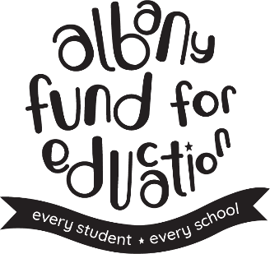
COVID-19 Educator Support
Grant Application

Because the Albany Fund for Education is not currently able to implement our traditional classroom grants - and because we know that our educators are going above and beyond for your students right now, even as your own lives are stressful and uncertain, the Albany Fund for Education Board has approved a new grant program.

City School District of Albany teachers and staff can request between $25-$100 in reimbursement for supplies/resources purchased to assist with online learning (e.g. Teachers Pay Teachers materials) or to directly support students (books, school supplies, etc.). We have up to $5,000 in grant funds available.

To request funds, please fill out this application in Word and save it as YOURLASTNAME_AFEGrant and email it with a clear photo of your receipts to albanyafe@gmail.com with the subject line: COVID grants. If you are unable to type the application, you may print it and send a scan or photo.

If there are non-related items on the receipt, please circle the items for which you are requesting reimbursement. We will review requests received by Thursday at 5pm each week for reimbursement beginning the following Thursday. Reimbursements will be issued as checks mailed to your home. If we have questions or concerns, we will contact you via email or phone.

Name:

School:

Role (grades/subjects taught, social worker, psychologist, etc.):

Total Grant Requested:

Home Address (for mailing check):

Email Address:

Phone:

Continued on next page….

Please describe the supplies/resources purchased. We will not be able to reimburse purchases without receipts provided. Provide as much detail as possible. You may add rows if needed. Minimum reimbursement is $25, maximum is $100:

Expense | Cost | Purpose
Ex. 10 sketchpads and 10 packs of colored pencils | $95 ($7/sketchpad, $2.50/pencils) | Distributed to students without art supplies at home to allow them to participate in art classes
Total Requested

I certify that these supplies/resources were purchased to benefit the students of the City School District of Albany. If supplies were purchased for student use, I certify that they have been distributed to students.

Signature Date

Please help us spread the word about the Albany Fund for Education and our grant opportunities to your fellow educators! Follow us on Facebook at:

https://www.facebook.com/AlbanyFundForEducation

AFE depends on friends like you to do our work. If you’re able, please consider donating through the payroll giving form in your open enrollment packet. We know that’s not an option for many right now. But just by sharing information about AFE and the impact we have on your work with others, you can help us help you!

